Real Estate Management System with Blockchain
Harshal Singh#
#Btech Mechatronics Engineering
Ajeenkya D Y Patil University Pune
¹harshal.singh@adypu.edu.in
*Ms Sneha Sarode and Dr Harshal Patil
Professor at ADYPU Pune

Abstract— This Paper explains about the currently running Real-estate systems, their flaws, security defects and unsuccessful service. Further giving the most satisfying solution to those problems. Trying to create more secured, fast, transparent, and immutable way to handle all property rental management system. Using the most secured technology Blockchain, Smart Contracts, and Cryptography for this project and solving all of the problems. Working with main network of Bitcoin and Ethereum will cost us very high and hence we are using test network named as Rinkeby Testnet for our transactions and wallet purpose. We will look into how this product makes place in market and how this idea helps in revolution in Real estate world.

Keywords— Blockchain, Ethereum Network, Cryptography, Testnetwork, Smart Contracts, Solidity.
- Introduction
In recent years Blockchain and Cryptocurrency called as Bitcoins is boosting a lot in the market as the new generations is more shifting towards the Etokens style currency and also the level security privacy and transparency they provide. The Blockchain is FINTECH disruptive technology based on cryptography which has been know of the main work of Satoshi Nakamoto ^{[1].} In 2018 Satoshi Nakamoto proposed a white paper which was the main components to maintain transactions of digital currency named Bitcoin. With introduction to Blockchain this world will be benefitted in Banking Sector, Education Sector, Finance Sector, Insurance Sector, and most important for this paper Real Estate Sector. After Several studies in this technology it has been conceptualized that this technology will bring revolutionary change in our real estate world. The most money saving, work saving, and labour-saving advantage of this technology is there is no need of any kind of middlemen or third party between landlord and renting person of properties like Houses, Building, Lands, Farms, Houses, etc. Most and most industries are developing day by day and whole world is giving their effort towards developing more and more urbanized cities and in urbanized cities the most rapidly increasing sector has always been real estate sector and this Blockchain technology will boost up whole real estate world to whole another level.
The Real Estate System is all dependent on the trust that is been builded up between three of the participants i.e The Landlord, The Tennant, and The Agent between both of them. But there is been lack of trust worthy assets in the new market and all of them are just trying to rush for more and more income which is not bad for an individual. These individuals sometimes don’t use the ethical way to earn and they break this trust bond and alter with the contract or agreement that is been made between landlord and rental person. As these Real estate system work on centralized system it is very easy to alter because it is been controlled by a single authority. Here enters the need for our Blockchain technology which will lead to immutable contracts.
The Blockchain is been known for its distributed peer-to-peer (P2P) public ledger for all transactions, eliminating the fear of tempering. As the Blockchain technology is and decentralized technology, therefor there is no single authority, and hence altering the data or contract is near to impossible.
According to Deloitte^{[2],[3]} , “Blockchain is just an another type of database which is responsible to store all the transactions and contracts details where anyone who is a part of the blockchain has access to the data and can verify and clear out every doubt of theirs anytime they want.”
By definition, a blockchain is a cryptographic link of blocks of information concerning transaction records. Each Block comprises a cryptographic hash of the Nonce (unique value), the preceding block hash, the creation timestamp, and transaction data (usually expressed as a Merkle tree and widely broadcast with a unique symbol). Each block consists of a unique hash function (alphanumeric string resulting from coding data with cryptographic private and public keys), a nonce (a unique integer or arbitrary constant value to the block), and a hash function from the preceding block. The initial block, known as the genesis block or block 0, comprises a collection of protocol instructions used by miners to solve puzzles and earn rewards, such as Configuration, Difficulty, Gas Limit, and Allocation. This protects the mechanism from attempts to modify the transaction.
This paper deeply explains the 3 types of blockchain, the Ethereum smart contract, and we used all these features to make our renting system more secure and close to immutable where every transaction is been carried in cryptocurrency.
- Problem Statement
The Existing Real Estate System has flaws such as the excessive number of paper work and documentations, longer bank transfer periods, and hefty estate agency fees. According to research transferring funds between banks can take up to days or more for bigger amounts, resulting in wastage of time and sometimes additional fees. While many technologies have been used in the real-estate and housing markets, there is a need for technologies that allow for the immutable and autonomous payment of a rental charge in a transparent, conflict-free manner without the use of a third person:
- Proposed Solution
The one and only solution for the main flaws and frauds happening inside the currently running system of the real estate system is honesty towards the work process but it won’t be possible without blockchain. So, Shifting to Solidity based smart contracts is anytime more secured and immutable as compared to the advocate attested documents. Storing all the transactions details and the signed files and documents in the paper or file will be the costliest and unsafe part, hence storing it in the block in the form of ledger and then deploying it to the network without any hesitation where it can be accessed anytime in its lifespan for verification and cross check as an transactions history. All of the details and transactions and smart contracts have been stored in ledger format in the blockchain so if anyone tries to temper with the data he has to go through the cryptographic hash function and even after that the whole blockchain will be disturbed.
- Literature Review
Jerinas Gresch et.al in the paper “International Conference on Business Information Systems” devised a system to verify diplomas, called UZHBS. The idea aimed to eliminate the disadvantages of paper diplomas while also lowering the likelihood of false certificates. Their technique differs from previous research in that they began by formalising seven UZH needs gleaned from stakeholder interviews. Their system's interface shows a window to users, and the architecture is built on two functions. The first function is the front-end, which receives a PDF document from the user, and the second is the back-end, which processes the document. The material's hash is combined with a smart-contract function and sent to the Ethereum Block-chain [4].

Ana Lidia Franzoni et.al in the paper “International Conference on Advanced Learning Technologies (ICALT)” made a system for their government called Prenda on the Ethereum Block-chain. The major purpose is to preserve credentials for instructors who have completed teacher training in Mexico. A smart-contract is constructed in this system, which contains a wallet for each teacher's fundamental data. Furthermore, the key information from the courses is kept in a smart-contract and published to the Block-chain. In their trial, 1,518 primary school teachers from six states on Mexico took part and kept their credentials in the Block-chain platform for eacher training [5].

Lucas M Palma et.al have discussed in paper “International Journal of Network Management” a prototype for incorporating Block-chain technology into the Brazilian educational system Once students complete their needed coursework, the researchers suggest keeping their academic records in Block-chain utilising smart-contracts. Their proposal's implementation creates a user interface based on three smart-contracts: Authority, Curriculum, and Diploma. Furthermore, the study's prototype operates on the public Ethereum Block-chain, with smart-contracts developed in the Solidity programming language. Future studies should include all academic data for kids from elementary school through graduate school, according to the researchers. The authors claim that their prototype system was the first to use Block-chain technology to issue diploma certificates [3].

Muhamed Turkanovic et.al, in the paper “A blockchain-based higher education credit platform” have put their focus on issuing and verification of diplomas. This research differs from the previous one in that their concept includes an EduCTX Blockchain wallet for each student to store their academic information. This student wallet allows them to view their credit report. They also make it possible for Higher Education Institutions (HEIs) to join the EduCTX network. They created their platform on top of the Ark Blockchain infrastructure, with the intention of expanding it to include smart contracts in the future [6].

Mahmood A Rashid et.al in the paper “Teduchain: A platform for crowdsourcing tertiary education fund using blockchain technology” have devised a new platform called TEduchain. This website lets students gather and manage finances by establishing a contract between them and their sponsors. The author platform was created to assist students with overcoming financial barriers to completion of their studies. To conduct this activity over the Blockchain network, TEduchain provides a user-friendly dashboard that allows students, fundraisers, and sponsors to connect rapidly [7].

- Proposed Methodology
This paper explains the research method employed in this investigation. The research technique is a methodical way to solving a problem. Its purpose is to create a research schedule. A proof of concept (POC) approach was utilised to show the idea of using a blockchain-based smart-contract model to fix the shortcomings in existing real-estate property management platforms in order to meet the study's objectives. The five steps of the proof of concept were planning, designing, execution, operation, and improvement (PDIOI). The purpose of the POC was to develop a Solidity Smart contract based on the Ethereum blockchain.
- Proof of Concept (POC):
Proof of Concept (PoC) is a technique for determining project applications and functionality. It's used to see how practical a project is and may be employed in a variety of areas, including finance, healthcare, and insurance. It may be utilised by both businesses and startups.
A proof of concept is essentially a prototype that is performed internally to provide insight into how a project works. This may be accomplished without spending any time or money. It may be utilised as an effective starting pad into the blockchain development sector.
- PDIOI Approach:
The Planning, Design, Implementation, Operation, and Improvement approach was utilized for this study. Huawei's PDIOI approach is used to implement Enterprise Engineering Projects (IEEP). This technique was ideal since it assisted in increasing agility, speeding up processes, and reducing and resolving complications throughout the implementation of the PoC artifact.

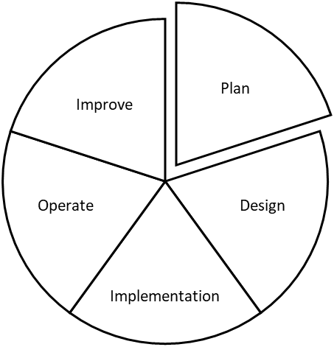
Fig 1 PDIOI

- Model Evaluation:
The model evaluation approach was based on the idea that a research's purposes, goals, or targets are determined at the outset, and that the evaluation process will be used to determine whether the goals have been met and, if not, why not questions will be used to correct any missing functionalities. The prototype was assessed utilizing goal-based assessment techniques, with the main goal of determining if the prototype achieves the established technical goals. An overview of the smart contract model is been shown in the figure bellow:

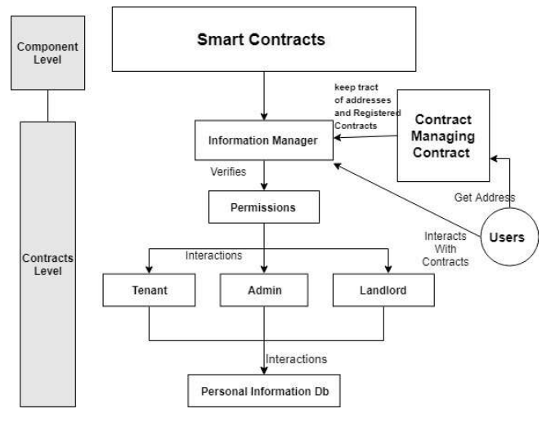
Fig 2 Overview of Smart contract Model
- Deploying Process
We need to know about few important terms before heading to deployment process:
- Solidity^{[8]}
Solidity is one and only programming language that is used to write down the code for smart contracts. Solidity is an object-oriented programming language designed for creating smart contracts on blockchains such as Ethereum. Solidity is a programming language inspired by JavaScript, Python, and C++, and it is designed to run on the Ethereum Virtual Machine (EVM). To put it another way, Solidity is the Ethereum programming language.
- Remix Ethereum IDE^{[9]}
Remix also known as Remix IDE is an open-source Ethereum IDE for writing, compiling, and debugging Solidity code. As a result, Remix may be a very useful tool in the creation of Web3 and dApps. In other words, if you're wondering "what is Remix," you've come to the correct spot! The parts that follow will teach you all you need to know about Remix's fundamentals. This information will assist you in determining whether or not it is the right tool for you. Furthermore, we'll tell you about an incredible platform that allows you to forgo time-consuming backend development while still delivering fantastic dApps.
- Metamask wallet
MetaMask is a cryptocurrency wallet that can hold Ether and other ERC-20 tokens. Decentralized applications, or dapps, can also be utilised with the wallet.
Steps to set-up metamask wallet:
- Go to Metamask official website^{[3]} and click on “Install Metamask for Chrome”
- Click on “Add to Chrome”
- Click on “Add Extension”
- Click on “Get Started” when metamask window appers.
- Click on “Create a New Wallet”.
- Follow the further instructions as per the metamask instructor.
- Do not forget to save the 12-word recovery phrase which is been displayed while creating wallet.
- Test network
Ethereum Platform has the ETokens named as Ether as a form of currency to perform each and every transaction. But for performing project ideas or for the sake of beginner’s use and for better understanding of the functioning of Ethereum main network the test network is been provided from the Ethereum itself.
These test network also have the ETokens same as the main network and these test Ethers have their specific faucet links to obtain free test Ethers and to perform several functions on test network
Some test network and their faucet link are been mentioned in the table below:
Table 1 Test network and Faucet link
Test Network | Faucet Link
Rinkeby Test Network | https://faucets.chain.link/rinkeby
Kovan Test Network | https://github.com/kovan-testnet/faucet
Ropsten Test Network | https://faucet.metamask.io/

- Results
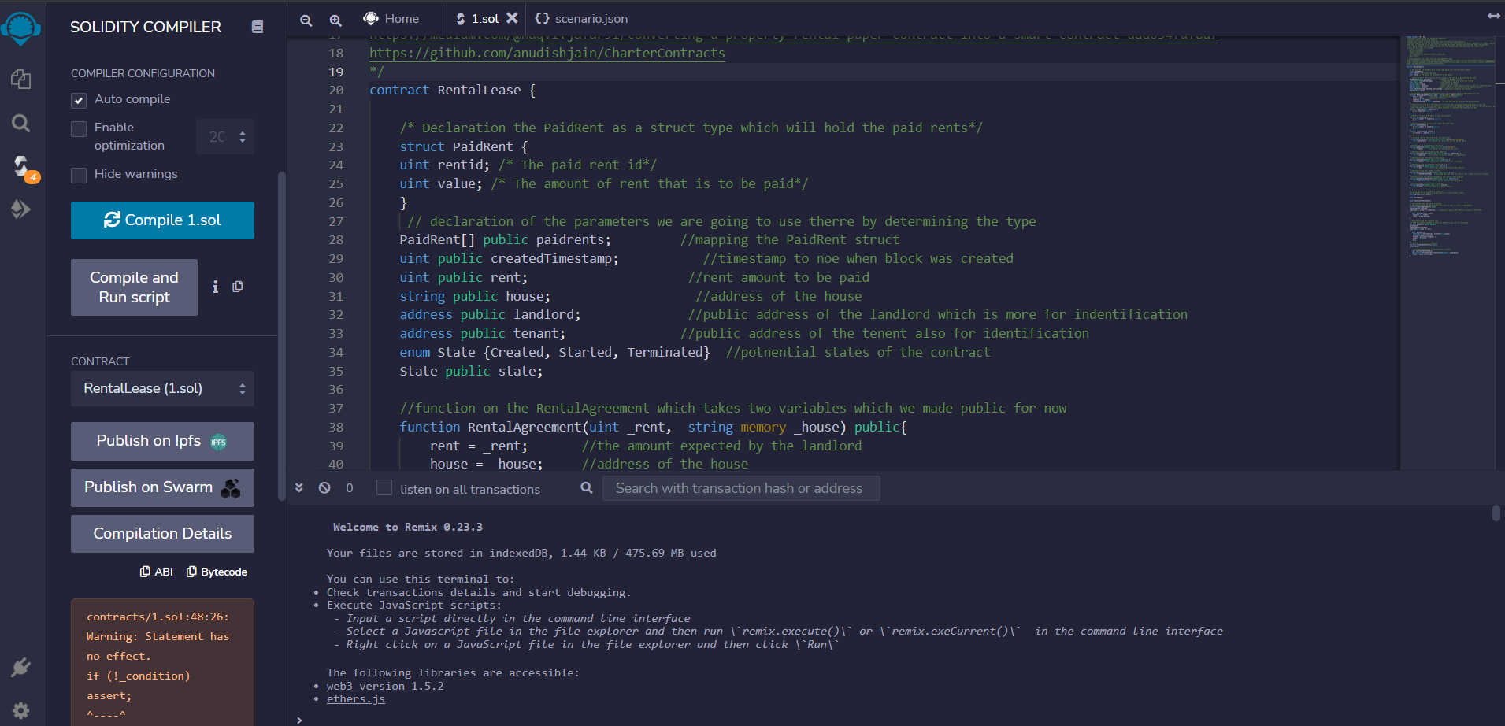
Fig 4.7 Compiling the solidity

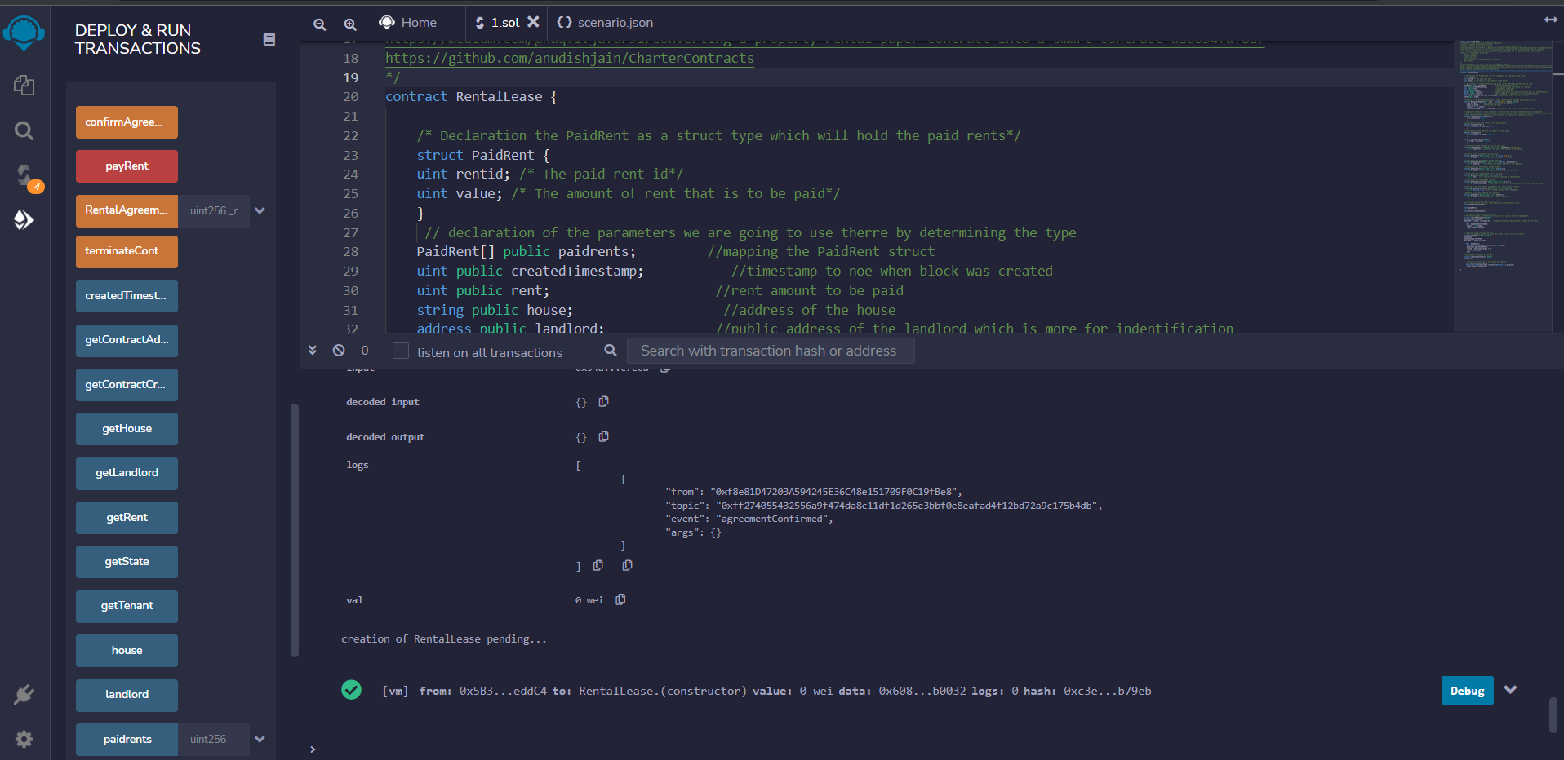
Fig 4.8 Deployed to our testnet

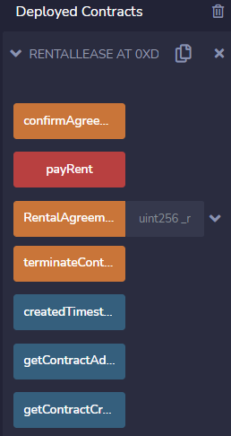
Fig 4.9 All contract function has been created
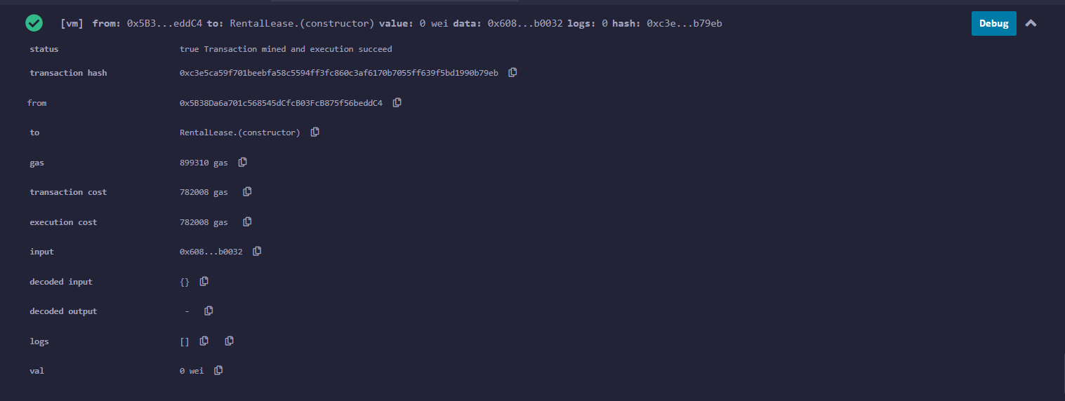
Fig 4.10 Terminal that shows every transaction requirement

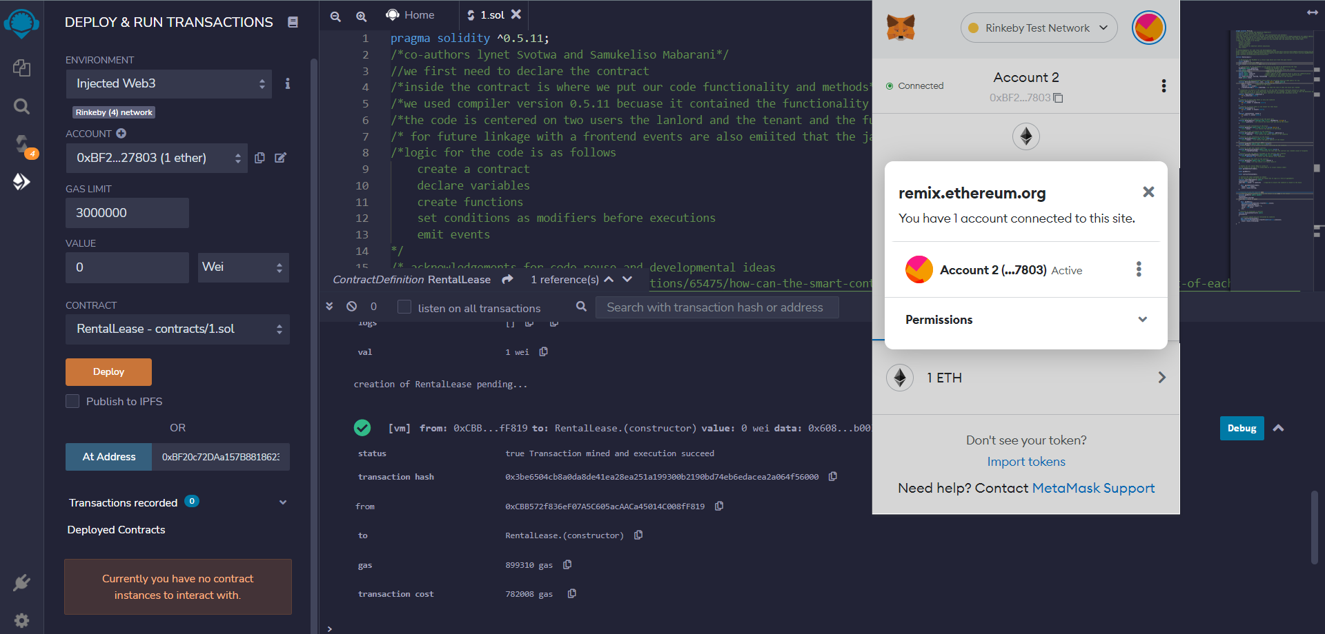
Fig 4.11 Connecting our injected web3(metamask) wallet to remix ide

- Conclusion

We have successfully developed a system that facilitates requesting a rent from the tenant and the tenant can approve the transaction. This system gives access to the rent agreement to both the parties at all times. Once the landlord has initiated the request for the transaction, the tenant can make the transfer from their Metamask mobile app. All of this is done through the chaincode that has all the required smart contracts in the package. The overall project has helped us learn the working of blockchain technology and smart contracts through Ethereum test network and test ethers.

References
- Satoshi Nakamoto. (2018) “Bitcoin: A Peer-to-Peer Electronic Cash System” https://bitcoin.org/bitcoin.pdf
- Deloitte. (2016) What is Blockchain? https://www2.deloitte.com/content/dam/Deloitte/uk/Documents/Inn ovation/deloitt e-uk- what-is-blockchain-2016.pdf.
- Deloitte. (2017) A New Game Changer for the Media Industry? https://www2.deloitte.com/content/dam/Deloitte/tr/Documents/tec hnology-mediatelecommunications/deloitte-PoV-blockchainmedia.pdf.
- Lucas M Palma, Martı́n AG Vigil, Fernando L Pereira, and Jean E Martina. Block-chain and smart-contracts for higher education registry in brazil. International Journal of Network Management, 29(3):e2061, 2019.
- Ana Lidia Franzoni, Cristina Cárdenas, and Alejandro Almazan. Using block-chain to store teachers’ certification in basic education in mexico. In 2019 IEEE 19th International Conference on Advanced Learning Technologies (ICALT), volume 2161, pages 217–218. IEEE, 2019.
- Lucas M Palma, Martı́n AG Vigil, Fernando L Pereira, and Jean E Martina. Block-chain and smart-contracts for higher education registry in brazil. International Journal of Network Management, 29(3):e2061, 2019.
- Mahmood A Rashid, Krishneel Deo, Divnesh Prasad, Kunal Singh, Sarvesh Chand, and Mansour Assaf. Teduchain: A platform for crowdsourcing tertiary education fund using blockchain technology. arXiv preprint arXiv:1901.06327, 2019.FLEXChip Signal Processor (MC68175/D), Motorola, 1996.
- M. Wohrer and U. Zdun, "Smart contracts: security patterns in the ethereum ecosystem and solidity," 2018 International Workshop on Blockchain Oriented Software Engineering (IWBOSE), 2018, pp. 2-8, doi: 10.1109/IWBOSE.2018.8327565.
- Amir Latif, R.M., Hussain, K., Jhanjhi, N.Z. et al. A remix IDE: smart contract-based framework for the healthcare sector by using Blockchain technology. Multimed Tools Appl (2020). https://doi.org/10.1007/s11042-020-10087-1

